C6 Sharmin Islam 31501842

Communications and Signal Processing

**3 Pulse Code Modulation**

**3.2 Setting up the PCM encoder**

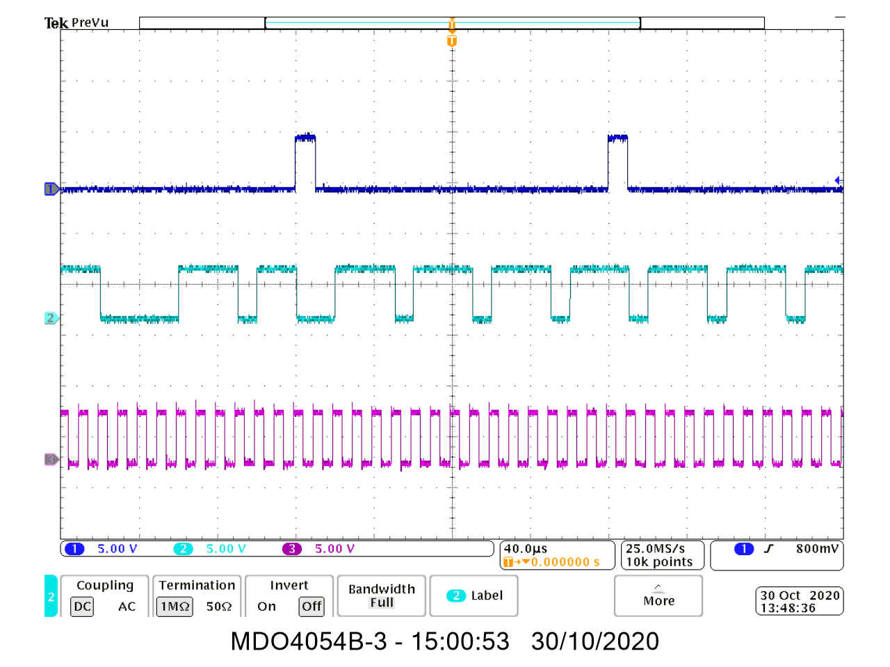

1. Binary number the pcm encoder module is outputting:

01110111

1. The difference between a sampled voltage and its closest quantisation level:

Quantisation error

1. The difference between the quantisation levels:

4/256= 15.625mV

1. Maximum quantisation noise:

4/(256*2)

1. Reduce quantisation error by having more quantisation levels and the number of quantisation levels can be changed by having more data.

**3.3 Decoding the PCM data**

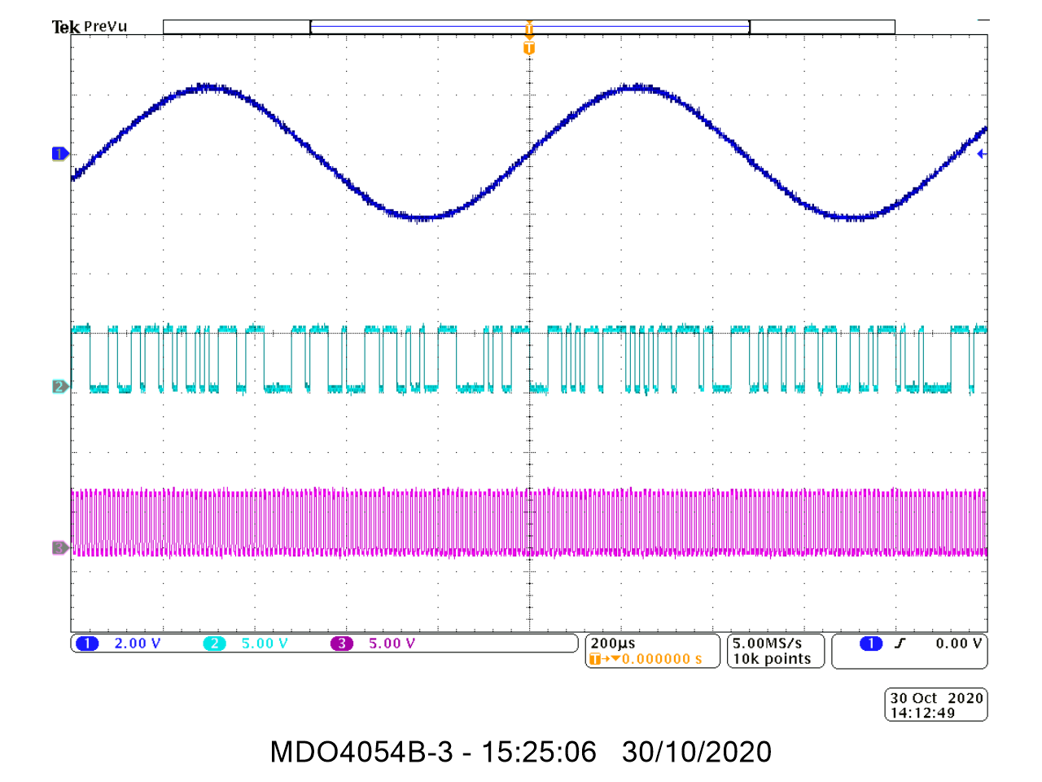

1. The PCM decoder’s ‘stepped’ output tells us this signal is a sinewave and speech signal.

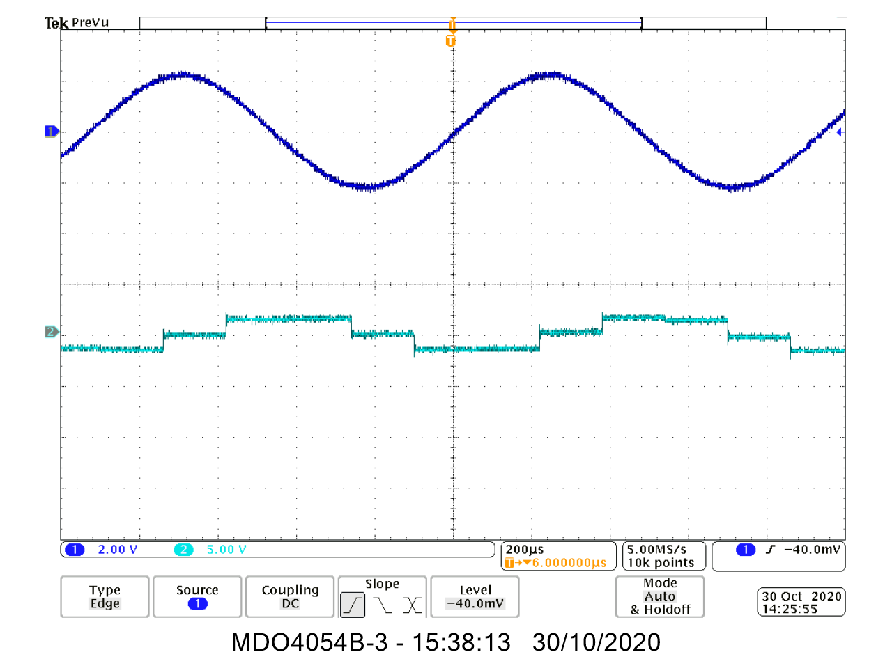

1. In order to reconstruct the message appropriately, the PCM decoder modules output needs to be put through a low pass filter.

**3.4 Encoding and decoding speech**

* 1. **Recovering the message**

1. The reconstructed message isn’t a perfect copy of the original message as there is a slight phase shift. As the amplitude of the message signal changes, the phase (shift) changes.

Quantisation error is the main reason (there is a difference between the sampled voltage and the closest quantisation level)

**4 Sinusoidal Sequences**

**4.1 Questions**

1.

1. The code will plot a sine graph of u(t) against t. t will go up in intervals of 0.01, going up to T=1.



1. F= 1/T, so I edited the code to make T=1/0.9 (as F=0.9 is what’s required)



1. F=1/T, F=1.1 therefore T=1/1.1



2. Time and phase shift

Plots multiple equations on the same graph



3. Time Scaling



**5 Random Signals**

**5.1 Questions**

1,2, and 3:

